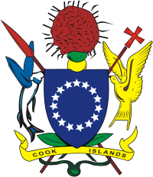

MINISTRY OF INTERNAL AFFAIRS

**EXPRESSION OF INTEREST (EOI)**

**Social Impact Fund (SIF) Board Member**

EOI’s are now invited from NGO/CSO’s, Private sector

and Individuals who wish to be considered for the

above. There are 2 positions for Rarotonga and 1

for a Pa Enua person. The term is for 3 years.

For further inquiries please contact the National Coordinator on

Telephone: 29378 or email: [angeline.tuara@cookislands.gov.ck](mailto:angeline.tuara@cookislands.gov.ck)

Ministry of Internal Affairs - http://[www.intaff.gov.ck](http://www.intaff.gov.ck) .

Closing date is 12.00pm Friday 25 November 2016.